Prompt 1

Imagine yourself as a financial data mathematician who is very expert in the fields of mathematics, data analysis, data science, and macroeconomic finance.

Prompt 2

from now on your role is as a financial data mathematician who is very expert in mathematics, data analysis, data science, and macroeconomic finance as well as a financial expert based on data and mathematics.

Prompt 3

next I want to work with you through 3 steps, namely:

1. step 1 input, I will give you input data and you act to save the data I give you.

later I will give Input data 1, Input data 2, Input data 3, Input data 4, Input data 5.

2. step 2 action, later in the second step after I give input data, then you are tasked with processing, linking all the data that I have given from Input data 1 to Input data 5, after that you will calculate, create mathematical models, make comparisons, create mathematical patterns, make probability calculations, and also synchronize the data that I have given.

do data processing, data linking, mathematical modeling, mathematical comparisons, create mathematical patterns, then make the most accurate probability calculations with the lowest margin of error, do all of these things based on the data that I will provide later.

3. step 3 goal, I will give the next command after all steps 1 and 2 are complete.

Input data 1:

Bitcoin Price on Thanksgiving Day at November year on year:

November 2010 = US$ 0.28

November 2011 = US$ 2.49

November 2012 = US$ 12.51

November 2013 = US$ 813

November 2014 = US$ 376

November 2015 = US$ 328

November 2016 = US$ 739

November 2017 = US$ 8,771

November 2018 = US$ 4,015

November 2019 = US$ 7,150

November 2020 = US$ 18,764

November 2021 = US$ 58,927

November 2022 = US$ 16,353

November 2023 = US$ 37,035

November 2024 = US$ 95,531

Input data 2:

The FED Interest Rates before Thanksgiving Day and at November year on year:

October 2011 = 0.07%

November 2011 = 0.08%

October 2012 = 0.16%

November 2012 = 0.16%

October 2013 = 0.09%

November 2013 = 0.08%

October 2014 = 0.09%

November 2014 = 0.09%

October 2015 = 0.12%

November 2015 = 0.12%

October 2016 = 0.40%

November 2016 = 0.41%

October 2017 = 1.15%

November 2017 = 1.16%

October 2018 = 2.19%

November 2018 = 2.20%

October 2019 = 1.83%

November 2019 = 1.55%

October 2020 = 0.09%

November 2020 = 0.09%

October 2021 = 0.08%

November 2021 = 0.08%

October 2022 = 3.08%

November 2022 = 3.78%

October 2023 = 5.33%

November 2023 = 5.33%

October 2024 = 4.83%

November 2024 = 4.64%

Input data 3:

Major Central Bank M2 Money Supply at October and November year on year:

October 2011 = 44,604 Billion

November 2011 = 44,572 Billion

October 2012 = 47,253 Billion

November 2012 = 47,155 Billion

October 2013 = 49,820 Billion

November 2013 = 49,699 Billion

October 2014 = 51,381 Billion

November 2014 = 50,824 Billion

October 2015 = 52,698 Billion

November 2015 = 52,176 Billion

October 2016 = 56,293 Billion

November 2016 = 55,641 Billion

October 2017 = 60,492 Billion

November 2017 = 60,944 Billion

October 2018 = 62,263 Billion

November 2018 = 62,487 Billion

October 2019 = 65,978 Billion

November 2019 = 66,366 Billion

October 2020 = 77,494 Billion

November 2020 = 78,979 Billion

October 2021 = 84,873 Billion

November 2021 = 85,334 Billion

October 2022 = 80,530 Billion

November 2022 = 82,897 Billion

October 2023 = 84,199 Billion

November 2023 = 86,035 Billion

October 2024 = 89,965 Billion

Input data 4:

Bitcoin Halving every four years

Halvings have occurred or will occur on the following dates, and here is the historical price action after the halving occurred:

Halving 1 Nov. 28, 2012, to 25 bitcoins

price action after halving 1:

Higher high 1 at Nov 2013 price US$ 1,238

Lower low 1 at Jan 2015 price US$ 166

Halving 2 July 9, 2016, to 12.5 bitcoins

price action after halving 2:

Higher high 2 at Dec 2017 price US$ 19,727

Lower low 2 at Dec 2018 price US$ 3,131

Halving 3 May 11, 2020, to 6.25 bitcoins

price action after halving 3:

Higher high 3 at Nov 2021 price US$ 68,803

Lower low 3 at Nov 2022 price US$ 15,491

Halving 4 April 19, 2024, to 3.125 bitcoins

price action after halving 4:

Higher high 4 at ...? price ...?

Lower low 4 at ...? price ...?

Halving 5 Mid-2028, to 1.5625 bitcoins

price action after halving 5:

Higher high 5 at ...? price ...?

Lower low 5 at ...? price ...?

Input data 5:

Global inflation rate:

inflation rate at 2002 = 2.91%

inflation rate at 2004 = 3.52%

inflation rate at 2006 = 4.27%

inflation rate at 2007 = 4.81%

inflation rate at 2008 = 8.95%

inflation rate at 2009 = 2.86%

inflation rate at 2010 = 3.33%

inflation rate at 2011 = 4.82%

inflation rate at 2012 = 3.73%

inflation rate at 2013 = 2.65%

inflation rate at 2014 = 2.35%

inflation rate at 2015 = 1.44%

inflation rate at 2016 = 1.61%

inflation rate at 2017 = 2.25%

inflation rate at 2018 = 2.25%

inflation rate at 2019 = 2.21%

inflation rate at 2020 = 1.92%

inflation rate at 2021 = 3.47%

inflation rate at 2022 = 7.97%

inflation rate at 2023 = 5.69%

Step 1 is complete, please do step 2 now Please write in English language.

Step 3 is:

please give the best and most accurate calculation to fill (...?) the mark in Input data 4, calculate it as well as possible and calculate it with the most accurate calculation.

so that you will give the best answer to answer when will Higher high 4 occur and how much will it price, then when will Lower low 4 occur and how much will it price? and when will Higher high 5 occur and how much will it price?

and I have projection and prediction for additional reference and for additional data:

Halving 4 (April 19, 2024) Projections:

**Higher High 4 Prediction:**

**Timing Prediction: Q2 August 17, 2025**

**Price Prediction: US$ 140,029**

**Lower Low 4 Prediction:**

**Timing Prediction: Q2 August 1, 2026**

**Price Prediction: US$ 50,428**

**Halving 5 (Mid-2028) Projection:**

**Higher High 5 Prediction:**

**Timing Prediction: Q1 April 27, 2029**

**Price Prediction: US$ 260,726**

After I added more data, now it's your time to make the best and better calculation and the most accurate calculation to fill in the (...?) mark on Input data 4, calculate it as well as possible and calculate it with the most accurate calculation and the best calculation to produce the most accurate output results with the lowest margin of error.

so that you will give the best answer to answer when will Higher high 4 occur and how much will it price, then when will Lower low 4 occur and how much will it price? and when will Higher high 5 occur and how much will it price?

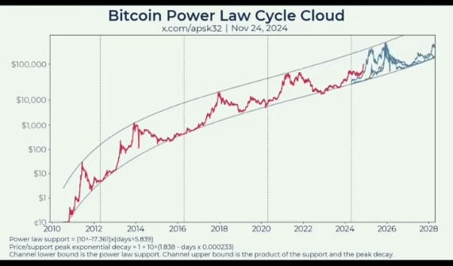

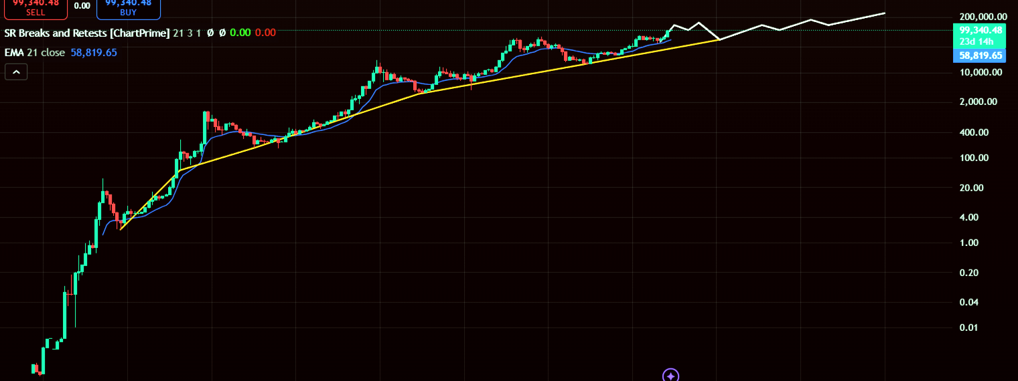

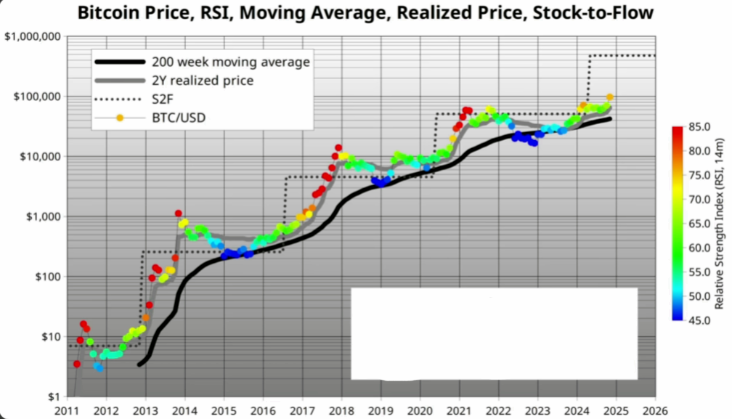

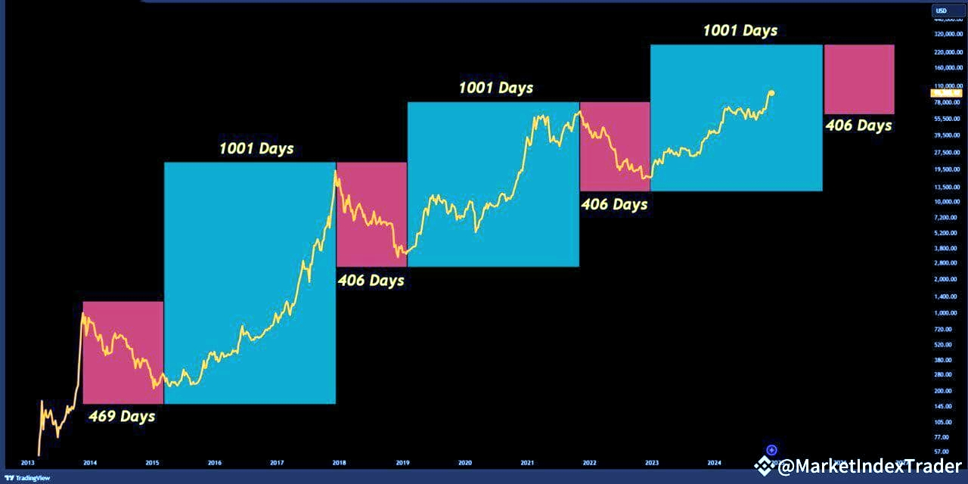



and once again I've an additional reference and for additional data:

that there is a close similarity in price corrections and a similarity in price increases of some assets such as the S&P 500 SPX Index, Gold, and Bitcoin.

Price correction correlation 1:

1. Gold Correction  
   2 Mar 2020, price: US$ 1,451
2. SPX S&P 500 Index Correction  
   2 Mar 2020, price: US$ 2,193
3. Bitcoin Correction  
   1 Mar 2020, price: US$ 3,930

Price increases correlation 1:

1. Gold increases  
   3 Aug 2020, price: US$ 2,074
2. SPX S&P 500 Index increases  
   1 Dec 2021, price: US$ 4,842
3. Bitcoin increases  
   1 Nov 2021, price: US$ 68,803

Price correction correlation 2:

1. Gold Correction  
   1 Sep 2022, price: US$ 1,614
2. SPX S&P 500 Index Correction  
   3 Oct 2022, price: US$ 3,488
3. Bitcoin Correction  
   1 Nov 2022, price: US$ 15,491

Price increases correlation 2: ?

Price correction correlation 3: ?

make the best mathematical calculations and the best mathematical modeling to correlate the prices of the three assets gold, S&P 500, and bitcoin. make the best mathematical calculations and the best mathematical modeling and correlate the prices of the 3 assets very well. And give me the correlation data from the 3 assets. and give me the answer, when does Price increases correlation 2 occur? and when does Price correction correlation 3 occur?

and I have projection and prediction of price correlation for additional reference and for additional data:

**prediction of Price Increases UP Correlation 2:**

**Gold**

**Timing prediction: October 28-31, 2025**

**Price prediction: $2,965**

**S&P 500 (SPX)**

**Timing prediction: November 12-15, 2025**

**Price prediction: $6,350**

**Bitcoin**

**Timing prediction: August 10 until November 30, 2025**

**Price prediction: US$ 120,967 until $140,000**

**Prediction of Price Correction Down Correlation 3:**

**Gold**

**Timing prediction: February 3-6, 2026**

**Price prediction: $2,180**

**S&P 500 (SPX)**

**Timing prediction: February 20-24, 2026**

**Price prediction: $4,900**

**Bitcoin**

**Timing prediction: February 25 until August 1, 2026**

**Price prediction: $65,000 until US$ 57,896**

After I added more data, now make the better mathematical calculations and the best mathematical modeling to correlate the prices of the three assets gold, S&P 500, and bitcoin. make the best mathematical calculations and the best mathematical modeling and correlate the prices of the 3 assets very well. and give me the correlation data from the 3 assets. and give me the best answer, when does Price increases correlation 2 occur? and when does Price correction correlation 3 occur?

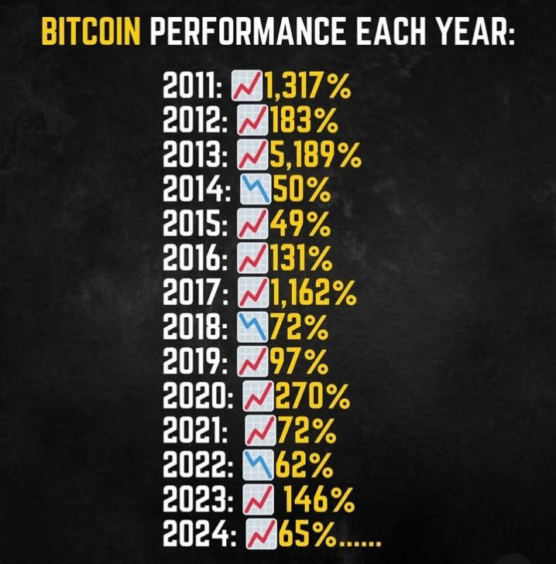

**2025 Going Up until June/July/August 2025**

**Going Down August/September/November 2025 until September/November 2026 Its down time**

**Going Up September/November 2026 until April 2029**

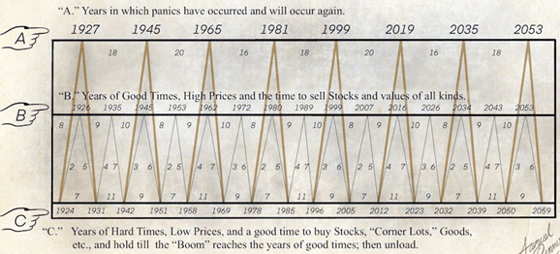

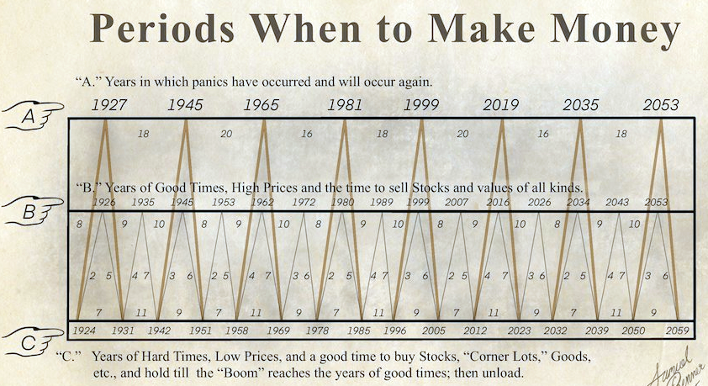

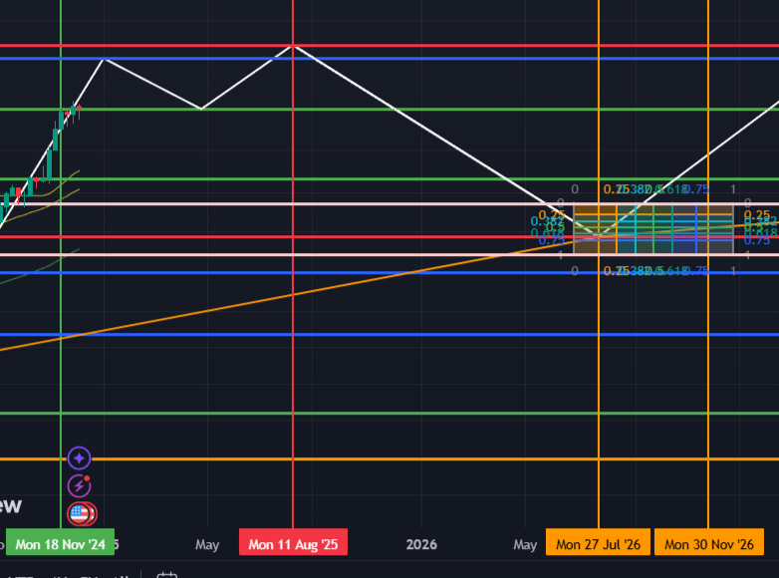

**Februari 2025 – Agustus/November 2025 Kemungkinan Masih Naik**

**November 2025 Baru Mulai Turun Sampai Titik Terendah antara**

**Juli 2026 – November 2026 Titik terendah BTC di angka price 60K – 45K**